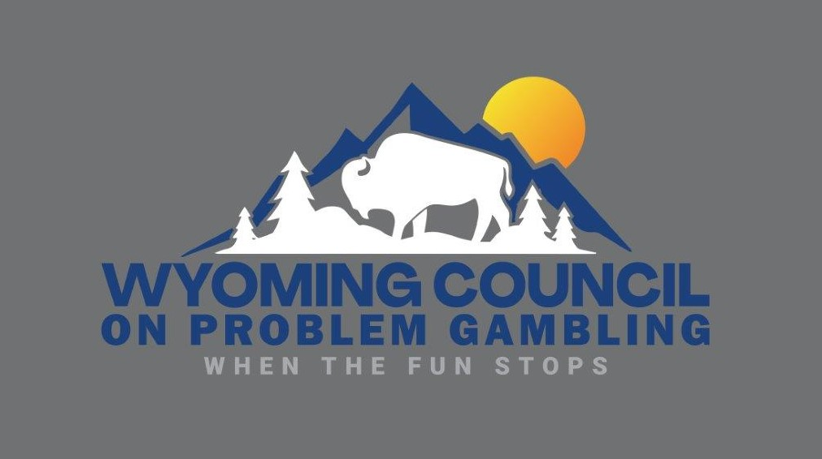

GROUP TRAINING REQUEST
The Wyoming Council on Problem Gambling (WCPG) offers one-hour problem gambling awareness classes that offer participants an introduction to the problem and disordered gambling. Classes are conducted by an ICGC qualified trainer.
The Wyoming Council on Problem Gambling (WCPG) offers an introduction class on problem gambling and a ninety-minute training on Problem Gambling: The Hidden Addiction, and participants will receive 1.5 CEUs.
The following requirements and conditions apply to all group training sessions, depending on the selected location.

Audio Visual | Equipment provided by Host/Sponsor | Room must be adequately equipped for PowerPoint and video presentation (with sound)
1-Hour Lunch and Learn | Class size: Minimum 4 | Class size: Maximum 20 per class | Administrative Fee: $100 per class
90-Minute Training (CEUs) | Class size: Minimum of 6 participants | Class size: Maximum of 20 per training | Administration Fee: $250 per training, and  $35 per participant

HERE’S HOW IT WORKS:
- Complete and return the GROUP TRAINING WORKSHEET. Upon receipt of the completed worksheet, WCPG will contact you to review the request and draft a training proposal to meet your needs. The proposal will include a statement of the associated administrative fees, an estimate of participant fees, and any travel expenses.

- Payment Guarantee: Upon acceptance of the training plan by your organization, WCPG will issue an invoice for the minimum guaranteed amount that must be paid to reserve your class schedule. The guaranteed amount will equal the training fee for your four or six participants minimum per class or training, plus associated administrative costs, and travel expenses when applicable.

- Cancellation Policy: Notice of cancellation for any class must be submitted in writing and be received by WCPG at least 3 business days prior to the scheduled class date. If the cancelled class cannot be rescheduled to another date, WCPG will refund the 4- or 6-person participant fees for the cancelled class. All administrative fees are non-refundable, and no refunds will be made for cancellations of less than 3 business days.

- Final Invoice: Upon completion of scheduled classes, a final invoice will be issued for the balance due, based on the actual number of participants in attendance. No adjustment or refunds will be made for classes or training where attendance falls short of the 4- to 6- person minimum guarantee. All invoices are due and payable upon receipt. WCPG will provide attendance verification for all participants upon payment in full of final invoice.

Please complete the Group Training Worksheet and return by mail, or email to:
Wyoming Council on Problem Gambling Ph: 307-620-2655
63 North Burritt Ave, Room 101-A email: admin@wyomingcpg.com
Buffalo, WY 82834
GROUP TRAINING WORKSHEET

COMPANY INFORMATION
Company Name:
Address:
City: State: Zip:
Contact Person:
Contact Phone: Fax:
Contact E-mail:
Total number of employees to be trained: (estimate)

PREFERRED TRAINING LOCATION
WCPG training room is located at:
Address: Bomber Mountain Civic Center
63 No. Burritt Avenue, Buffalo, WY 82834
Dept/Room: Wyoming Room
Directions/special instructions:

REQUESTED TRAINING SCHEDULE:

Date Start Time Estimated # Employees
- _______________ _________ ______________
- _______________ _________ ______________
- _______________ _________ ______________
- _______________ _________ ______________
- _______________ _________ ______________
- ______________ _________ ______________
- _______________ _________ ______________
- _______________ _________ ______________
- _______________ _________ ______________
- _______________ _________ ______________
- _______________ _________ ______________
- _______________ _________ ______________

If you have any questions or need additional information regarding our Group Training Program, please call Adelaide Wilson at 307-620-2655, or email admin@wyomingcpg.com.

